CROP RECOMMENDATION SYSTEM

CAPSTONE PROJECT

Submitted in partial fulfillment of the requirements of the

Post Graduate Certification Program
in
Artificial Intelligence and Machine Learning

By

IMTIAYZ ALAMSHAH 2024AIML132
LIPSA MISHRA 2024AIML067
RAIBAGKAR HARSHAL GOPALRAO 2024AIML057
SHAH HIMA KIRANBHAI 2024AIML011
UPADYAYULA V SHARMA 2024AIML070

Under the supervision of

Prof. Aniruddha Dasgupta

Project work carried out at

BIRLA INSTITUTE OF TECHNOLOGY AND SCIENCE
Pilani (Rajasthan) INDIA

(October,2025)

PGCP AIML CAPSTONE PROJECT

CROP RECOMMENDATION SYSTEM

Submitted in partial fulfillment of the requirements of the

PGCP - Artificial Intelligence and Machine Learning

By

IMTIAYZ ALAMSHAH 2024AIML132
LIPSA MISHRA 2024AIML067
RAIBAGKAR HARSHAL GOPALRAO 2024AIML057
SHAH HIMA KIRANBHAI 2024AIML011
UPADYAYULA V SHARMA 2024AIML070

Under the supervision of

Prof. Aniruddha Dasgupta

Project work carried out at

BIRLA INSTITUTE OF TECHNOLOGY AND SCIENCE
PILANI (RAJASTHAN)

(October, 2025)

ACKNOWLEDGEMENTS

We express our deep sense of gratitude to BITS, Pilani for providing an opportunity to pursue our project on “Crop Recommendation System”.

We thank our mentor, Prof. Aniruddha Dasgupta for the constant support and guidance which resulted in the successful completion of the project within the specified time. His unflinching help and encouragement were a constant source of inspiration to us.

We would also like to thank all our professors, who taught us the basic and advanced concepts of artificial intelligence and machine learning in such a nuanced manner, during this certification program.

We would also like to thank our respective families and organizations for supporting us through this journey.

IMTIAYZ ALAMSHAH (2024AIML132)
LIPSA MISHRA (2024AIML067)
RAIBAGKAR HARSHAL GOPALRAO (2024AIML057)
SHAH HIMA KIRANBHAI (2024AIML011)
UPADYAYULA V SHARMA (2024AIML070)

BIRLA INSTITUTE OF TECHNOLOGY AND SCIENCE, PILANI

CERTIFICATE

This is to certify that the Capstone Project entitled “Crop Recommendation System”
and submitted by IMTIYAZ ALAMSHAH (2024AIML132) in partial fulfillment of the requirements of PGCP AIML Capstone Project, embodies the work done by him/her under my supervision.

Place : Hyderabad Signature of the Mentor

Date : 22-10-2025 Name : Prof. Aniruddha Dasgupta

BIRLA INSTITUTE OF TECHNOLOGY AND SCIENCE, PILANI

CERTIFICATE

This is to certify that the Capstone Project entitled “Crop Recommendation System” and submitted by LIPSA MISHRA (2024AIML067) in partial fulfillment of the requirements of PGCP AIML Capstone Project, embodies the work done by him/her under my supervision.

Place : Hyderabad Signature of the Mentor

Date : 22-10-2025 Name : Prof. Aniruddha Dasgupta

BIRLA INSTITUTE OF TECHNOLOGY AND SCIENCE, PILANI

CERTIFICATE

This is to certify that the Capstone Project entitled “Crop Recommendation System” and submitted by RAIBAGKAR HARSHAL GOPALRAO (2024AIML057) in partial fulfillment of the requirements of PGCP AIML Capstone Project, embodies the work done by him/her under my supervision.

Place : Hyderabad Signature of the Mentor

Date : 22-10-2025 Name : Prof. Aniruddha Dasgupta

BIRLA INSTITUTE OF TECHNOLOGY AND SCIENCE, PILANI

CERTIFICATE

This is to certify that the Capstone Project entitled “Crop Recommendation System” and submitted by SHAH HIMA KIRANBHAI (2024AIML011) in partial fulfillment of the requirements of PGCP AIML Capstone Project, embodies the work done by him/her under my supervision.

Place : Hyderabad Signature of the Mentor

Date : 22-10-2025 Name : Prof. Aniruddha Dasgupta

BIRLA INSTITUTE OF TECHNOLOGY AND SCIENCE, PILANI

CERTIFICATE

This is to certify that the Capstone Project entitled “Crop Recommendation System” and submitted by UPADYAYULA V SHARMA (2024AIML070) in partial fulfillment of the requirements of PGCP AIML Capstone Project, embodies the work done by him/her under my supervision.

Place : Hyderabad Signature of the Mentor

Date : 22-10-2025 Name : Prof. Aniruddha Dasgupta

BIRLA INSTITUTE OF TECHNOLOGY & SCIENCE, PILANI
2024-25

PGCP AIML CAPSTONE PROJECT

Project Title : Crop Recommendation System

Name of Mentor : Prof. Aniruddha Dasgupta

Name of Student : IMTIAYZ ALAMSHAH, LIPSA MISHRA, RAIBAGKAR HARSHAL GOPALRAO, SHAH HIMA KIRANBHAI, UPADYAYULA V SHARMA

ID No. of Student : 2024AIML132, 2024AIML067, 2024AIML057, 2024AIML011, 2024AIML070

ABSTRACT

Agriculture is the backbone of India’s economy, supporting a majority of the rural population. However, farmers often face challenges in selecting the most suitable crop due to variations in soil type, climatic conditions, and lack of technical knowledge. The Crop Recommendation System in India addresses this issue by providing a scientific and data-driven approach to crop selection. It leverages agricultural and environmental data to assist farmers in making informed decisions that can enhance productivity and sustainability.
The system uses machine learning algorithms to analyze parameters such as soil type, pH level, nutrient composition, temperature, and rainfall. Based on these inputs, it predicts the most appropriate crop for a specific region. By integrating technology with agriculture, the project promotes efficient resource utilization, improved crop yield, and long-term food security. This initiative demonstrates the potential of artificial intelligence in revolutionizing traditional farming practices in India.
.

TABLE OF CONTENTS

Table of Contents
ABSTRACT 9
TABLE OF CONTENTS 10
Problem Statement 7
Objective of the Project 7
Objectives include: 7
Machine Learning Process Flow (Architecture) 8
Resources or Prerequisite 8
Libraries & Frameworks: 8
Potential data challenges & risks in doing the project 9
Proposed Methodology 9
Detailed Plan of Work 10
Dataset 11
Pre-Processing and Feature Engineering 12
Feature Combination 12
Binning 12
Exploratory Data Analysis (EDA) Summary 13
Overall Objectives: 13
Top 10 crop distribution 13
Feature Distribution 14
Feature Correlation Matrix 15
Statistical Summary 16
Machine Learning Modeling & Techniques Applied 16
Objective: 16
Modeling Approach: 16
Models Trained: 17
Model Evaluation Summary: 17
Code & Screenshots 18
Deployment 26
Objective: 26
Tools and Technologies Used: 26
Deployment Architecture Overview: 26
Project Folder Structure: 26
Key Insights & Impactful/Important Features 27
Key Insights 27
Important Features Identified 27
1. Nitrogen (N): Affects leaf development and vegetative growth; critical for cereals and leafy vegetables. 27
2. Phosphorus (P): Enhances root strength, flowering, and seed formation. 27
3. Potassium (K): Improves water retention, disease resistance, and overall crop resilience. 27
4. pH Value: Determines nutrient solubility and microbial activity in soil. 27
5. Rainfall: Influences irrigation planning and crop selection, particularly for rainfed farming systems. 27
6. Temperature: Regulates germination, flowering, and maturity; crops like wheat and rice have distinct optimal temperature ranges. 27
Future Work / Scope of improvements 28
Checklist of items for the Final report 29

Problem Statement

Agriculture in India is highly dependent on environmental conditions and soil characteristics, which vary widely across regions. Most farmers rely on traditional knowledge or past experience to decide which crop to cultivate, often without access to scientific data or expert guidance. This leads to suboptimal crop choices, reduced productivity, and financial losses.
Unpredictable weather patterns, irregular rainfall, and soil degradation further complicate the decision-making process. Farmers are frequently unaware of how soil nutrients, pH level, or moisture content affect crop suitability. Consequently, they may invest time and resources into crops that are not well-suited to their land or local climate.
Therefore, there is a pressing need for an intelligent, data-driven system that can recommend the most suitable crop for a given location based on real-time agricultural parameters. Such a system can help optimize yields, ensure sustainable farming, and support better livelihood outcomes for Indian farmers.

Objective of the Project
The objective of the Crop Recommendation System in India is to design and implement an intelligent, data-driven application capable of predicting the most suitable crop for a given region using machine learning and environmental analysis. The project focuses on building a technically robust solution that processes agricultural data efficiently and provides accurate, actionable insights to farmers.

Objectives include:
- To collect and pre-process agricultural datasets containing soil, weather, and crop parameters.
- To perform data cleaning, normalization, and feature extraction for model training.
- To implement and compare machine learning algorithms such as Random Forest, Decision Tree, and Support Vector Machine for crop prediction.
- To evaluate model accuracy using appropriate metrics like precision, recall, and F1-score.
- To develop a web or desktop-based user interface for inputting soil and climate data.
- To integrate the trained model with the interface to generate real-time crop recommendations.
- To deploy the system for testing and validate its performance using real-world agricultural data.

Machine Learning Process Flow (Architecture)

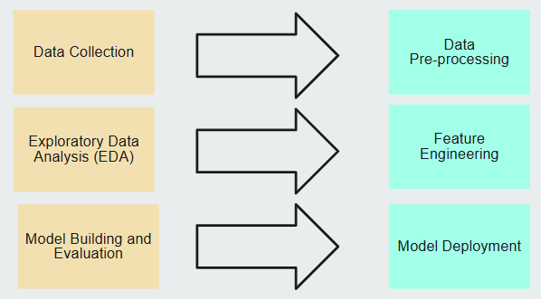

Resources or Prerequisite
Data Resources: Collect data from various sources https://etrain.info/in, https://indianrail.gov.in

Libraries & Frameworks:
- pandas, numpy for data manipulation
- matplotlib, seaborn for visualization
- scikit-learn, xgboost for machine learning
- pickle, streamlit for deployment
- Software: Python

Potential data challenges & risks in doing the project
Developing a Crop Recommendation System involves handling complex and diverse agricultural datasets, which presents several data-related challenges and risks. The accuracy and effectiveness of the model depend heavily on the quality, completeness, and consistency of data used for training and testing.
One major challenge is the availability and accessibility of reliable agricultural data. Data on soil nutrients, weather conditions, and crop yields are often scattered across multiple government and private sources, making collection and integration difficult. Additionally, data inconsistency and missing values can impact the performance of machine learning algorithms, requiring extensive preprocessing and cleaning.
Another risk is regional data imbalance, where certain states or soil types are overrepresented, leading to biased predictions. Temporal changes in climate patterns and soil fertility can also make historical data less relevant over time. Finally, ensuring data privacy and security is critical, especially when integrating data from farmers or government databases. Addressing these challenges is essential to ensure the system’s accuracy, scalability, and long-term reliability.

Proposed Methodology
The Crop Recommendation System in India aims to utilize data analytics and machine learning techniques to predict the most suitable crop for a given region based on soil and environmental parameters. The proposed methodology is divided into systematic stages that ensure efficient data handling, model training, and user interaction.
- Data Collection:
Relevant datasets are collected from credible sources such as the data.gov.in, Kaggle data source, and government open data portals. The datasets include soil characteristics (pH, nitrogen, phosphorus, potassium), weather parameters (temperature, rainfall), and regional crop yield data.
- Data Preprocessing:
Collected data undergo cleaning to remove missing, duplicate, or inconsistent entries. Feature scaling and normalization are applied to ensure uniformity. Outliers are identified and treated to improve model stability.
- Model Development:
Various machine learning algorithms—such as Random Forest, Decision Tree, Support Vector Machine (SVM), and K-Nearest Neighbor (KNN)—are trained and tested on the processed data. The models are tuned using hyperparameter optimization techniques to enhance prediction accuracy.
- Model Evaluation:
Performance is assessed using metrics like accuracy, precision, recall, F1-score, and confusion matrix. Cross-validation techniques are applied to ensure the model’s generalization and reliability.
- Testing and Validation:
The system is tested using real-time or region-specific data to validate the accuracy of recommendations. Feedback from agricultural experts and field trials can further refine the model.
- Deployment and Future Enhancement:
After validation, the system is deployed for use by farmers and agricultural departments. Future enhancements may include IoT-based sensor integration, real-time weather APIs, and mobile application development for wider accessibility.

Detailed Plan of Work

Week 1-2: Data exploration and preprocessing.
Week 3-4: Feature engineering and EDA.
Week 5-6: Model training and hyperparameter tuning.
Week 7-8: Evaluation, deployment, and documentation
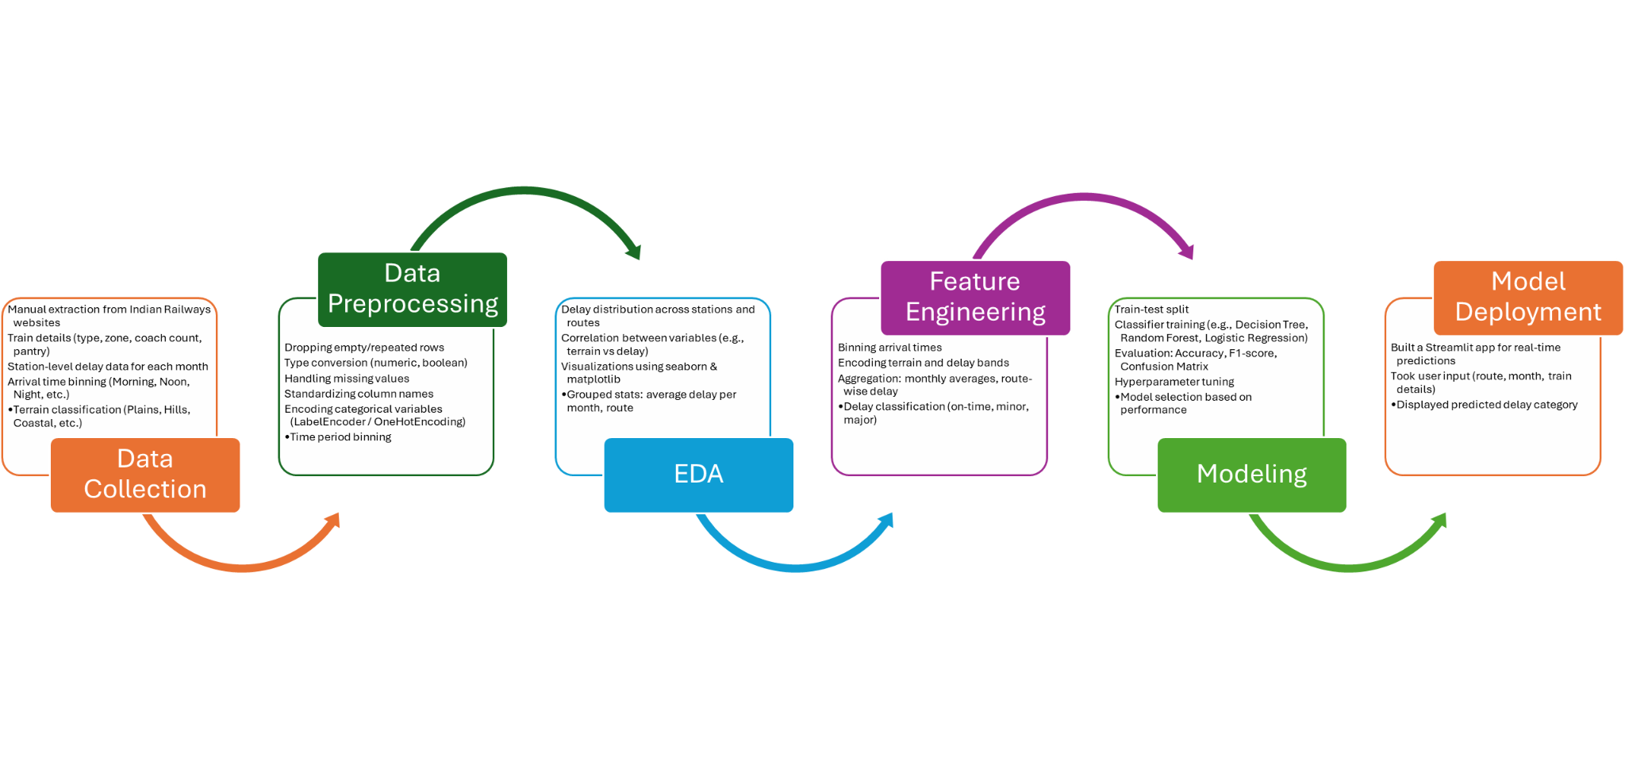
Problem Definition:
Identified the need to intelligent, data-driven system that can recommend the most suitable crop for a given location based on real-time agricultural parameters.
Data Collection:
Collected crop data from Kaggle.com.
This dataset provides detailed information used to recommend suitable crops based on essential soil nutrients and climatic factors. It includes measurements of Nitrogen (N), Phosphorus (P), Potassium (K) content in the soil, along with soil pH, rainfall, and temperature. By analyzing these parameters, the dataset helps in identifying the most appropriate crop to grow under specific environmental and soil conditions, supporting precision agriculture and efficient land use.
Data Preprocessing
Cleaned and standardized data, handled missing values, encoded categorical features (e.g., terrain, time slots).
Exploratory Data Analysis (EDA)
Visualized different feature distribution, data statistics.
Feature Engineering
Created derived features such as NPK_sum, NPK_ratio, NK_ratio, PK_ratio, ph_acidic, ph_neutral, ph_alkaline.
Model Building and Evaluation
Trained multiple classification models (Random Forest, XGBoost, etc.).
Evaluated using accuracy, F1-score, and confusion matrix to select the best-performing model.
Model Deployment
Deployed the final model using Streamlit, allowing users to input parameters and get recommended crop with confidence..

Dataset
The dataset used in the Crop Recommendation System in India forms the foundation for training and evaluating the machine learning models. It consists of agricultural and environmental parameters that directly influence crop growth and yield. Each record in the dataset represents a unique set of soil and climatic conditions, along with the corresponding crop that thrives best under those conditions.
The dataset contains the following features (independent variables):
- Nitrogen (N): Indicates the nitrogen content in the soil, essential for leaf growth and overall plant development.
- Phosphorus (P): Represents the phosphorus level in the soil, important for root development and energy transfer.
- Potassium (K): Measures the potassium content, crucial for water regulation, disease resistance, and fruit quality.
- pH Value: Denotes the acidity or alkalinity of the soil, which affects nutrient absorption and crop suitability.
- Rainfall: Average annual rainfall (in millimetres) recorded in the region, influencing water availability for crops.
- Temperature: The average temperature (in degrees Celsius), determining the thermal conditions suitable for different crops.
The target variable in the dataset is Crop, which specifies the name of the crop best suited for the given combination of soil nutrients, pH level, rainfall, and temperature. The dataset is typically labelled, meaning each data point has a known crop type associated with its environmental conditions.
This structured dataset enables supervised machine learning algorithms to learn the relationships between soil-climate parameters and optimal crop types. Once trained, the model can predict the most suitable crop for any new set of input parameters, making it a powerful decision-support tool for Indian farmers.
Total 40 types of Crop Labels are available in the data:
BlackPepper, BottleGourd, Brinjal, Cabbage, Cardamom, Cauliflower, Coriander, Cotton, Cucumber, Drumstick, Garlic, Grapes, HorseGram, JackFruit, Jowar, Jute, LadyFinger, Maize, Mango, Moong, Onion, Orange, Papaya, Pineapple, Potato, Pumpkin, Radish, Ragi, RapeSeed, Rice, SoyaBean, Sunflower, SweetPotato, Tomato, Turmeric and Wheat

Pre-Processing and Feature Engineering

Feature Combination
Created new features by feature combinations:
- NPK_Sum
- NP_Ratio
- NK_Ratio
- PK_Ratio

Binning
Created new features by binning:
- ph_acidic, ph_netural, ph_alkaline
- temp_cold, temp_moderate, temp_warm, temp_hot

Exploratory Data Analysis (EDA) Summary

Overall Objectives:
The goal of the EDA was to understand:
- The distribution of delays across trains and months
- Variability in terrain, platform availability, and route length
- Potential correlations between features like station count, coach type, and delay behavior

Top 10 crop distribution
Feature 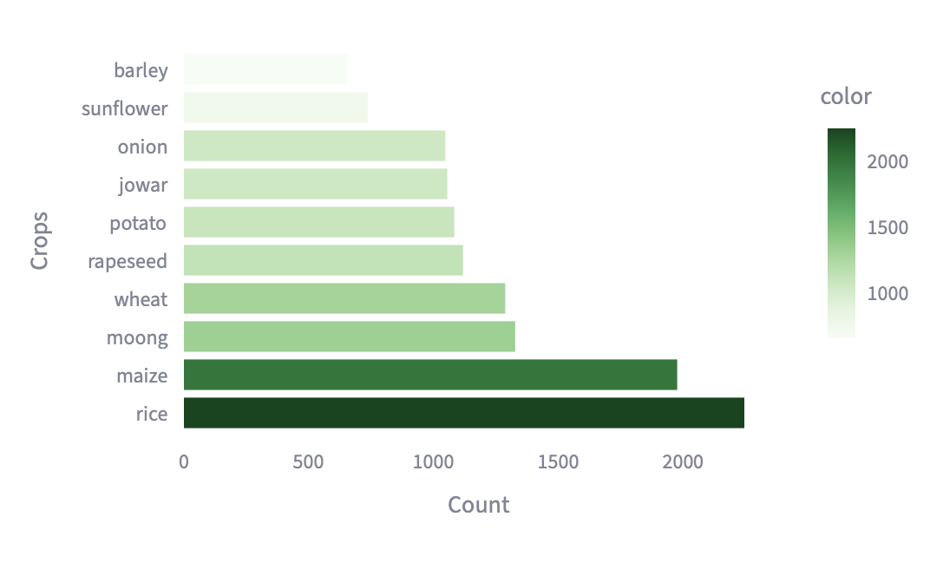

Feature Distribution
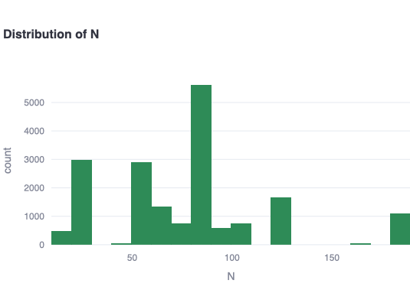 | 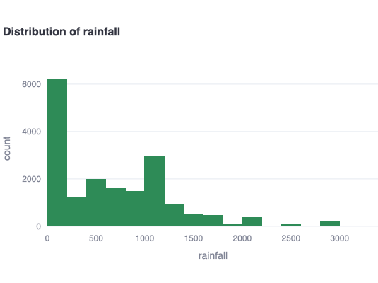
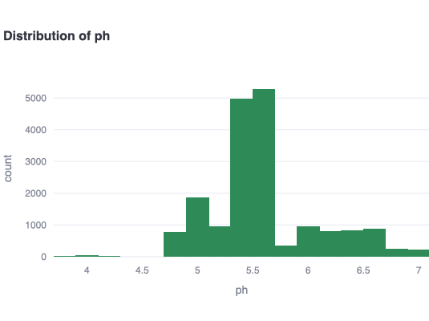 | 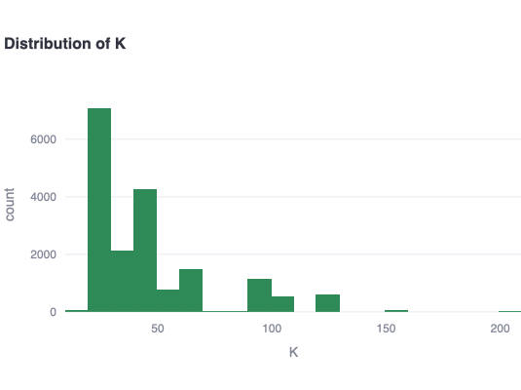
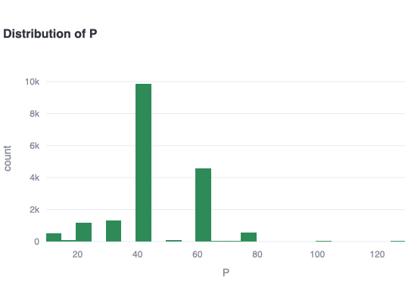 | 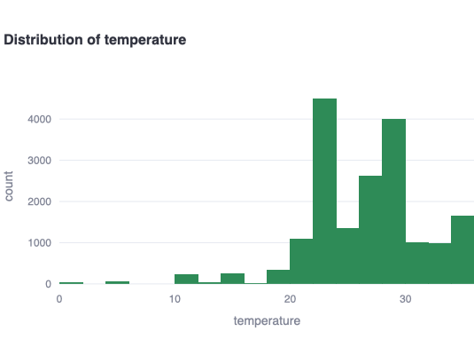

Feature Correlation Matrix
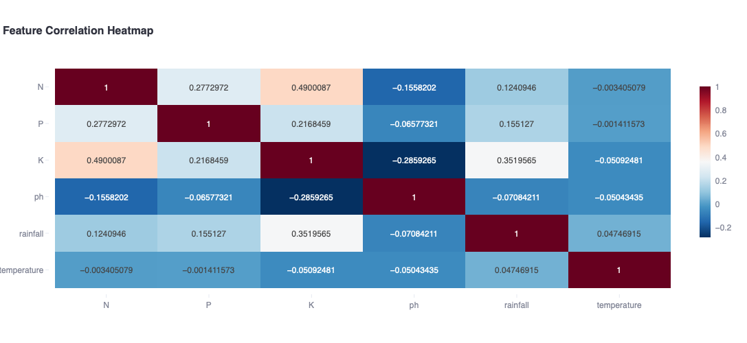

Statistical Summary
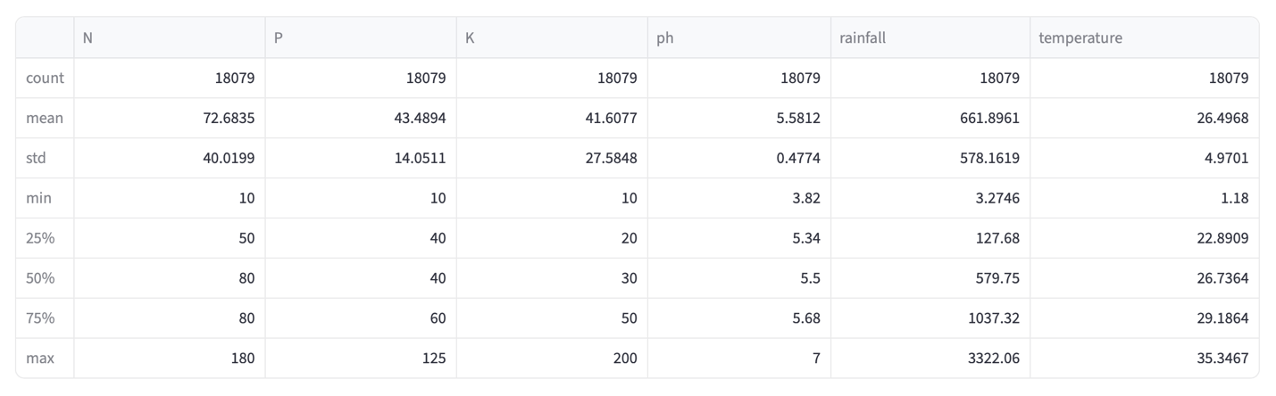

Machine Learning Modeling & Techniques Applied

Objective:

The Crop Recommendation System in India relies on machine learning techniques to predict the most suitable crop based on soil and environmental parameters such as nitrogen (N), phosphorus (P), potassium (K), pH value, rainfall, and temperature. The project adopts a supervised learning approach, where labeled data (features with corresponding crop types) is used to train predictive models capable of making accurate recommendations for unseen inputs.

Modeling Approach:

We followed a consistent pipeline for all models:
- Preprocessed and engineered features using processed_df
- Encoded categorical variables and binned numerical ones
- Used train_test_split() with stratification for fair model evaluation
- Evaluated using metrics like Accuracy, Confusion Matrix, and F1-score
- Saved each model and its corresponding input column structure and imputer (if needed)

Models Trained:
- Random Forest
- XGBoost
- Logistic Regression
- Support Vector Machine
- Decision Tree
- Neural Networks
- Naïve Bayes
- K-nearest neighbors

Model Evaluation Summary:
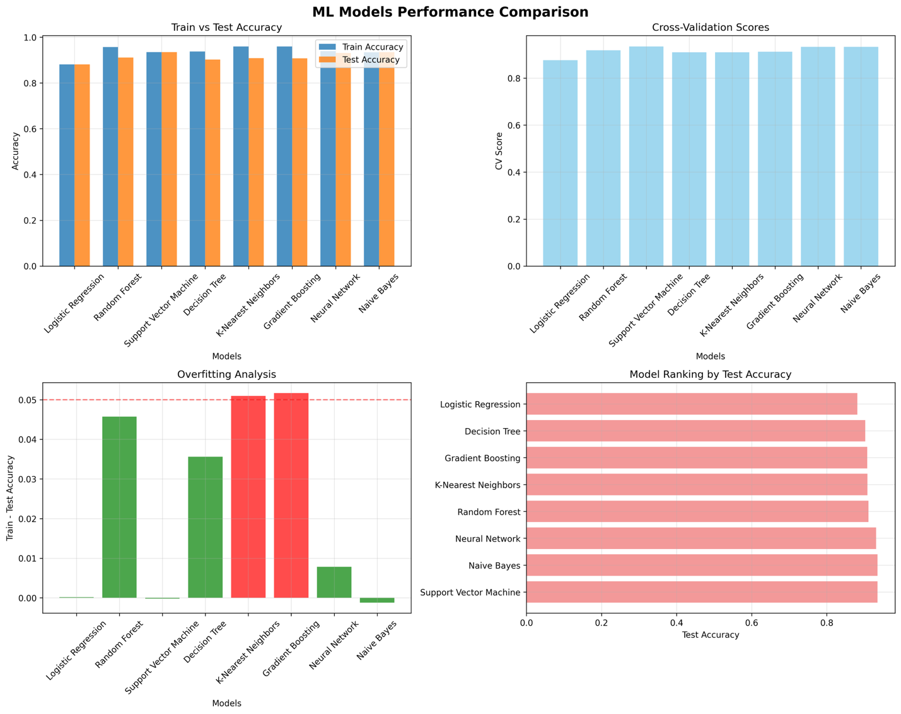

Code & Screenshots
- Github repo : https://github.com/ankitprjts/bitsGrp15Project
- Screenshots from project:
  - Run_complete_pipeline.py
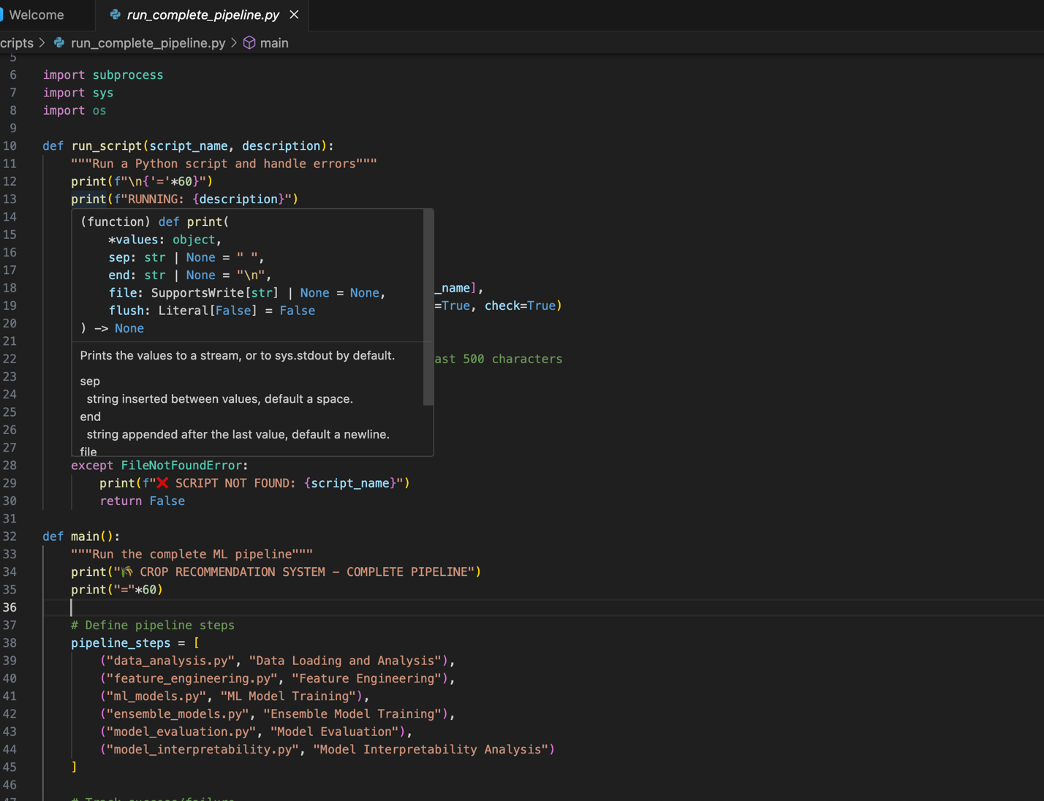
  - Data_analysis.py
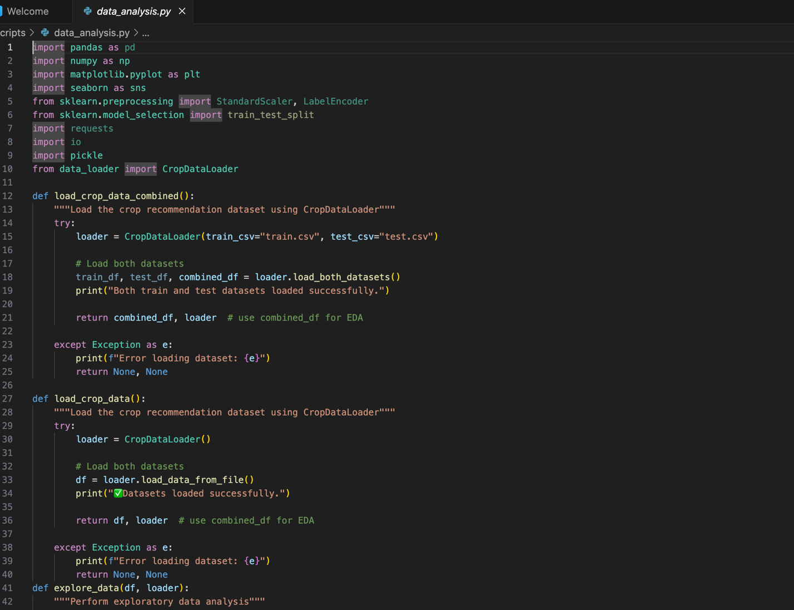

  - feature_engineering.py

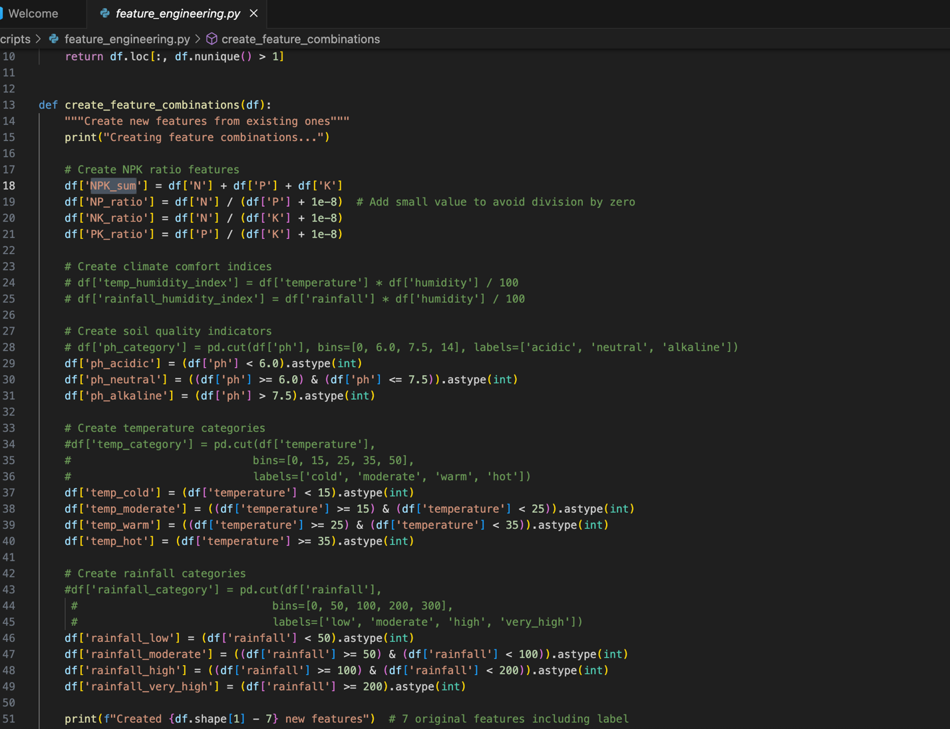

  - ml_model.py

  - ensemble_model.py
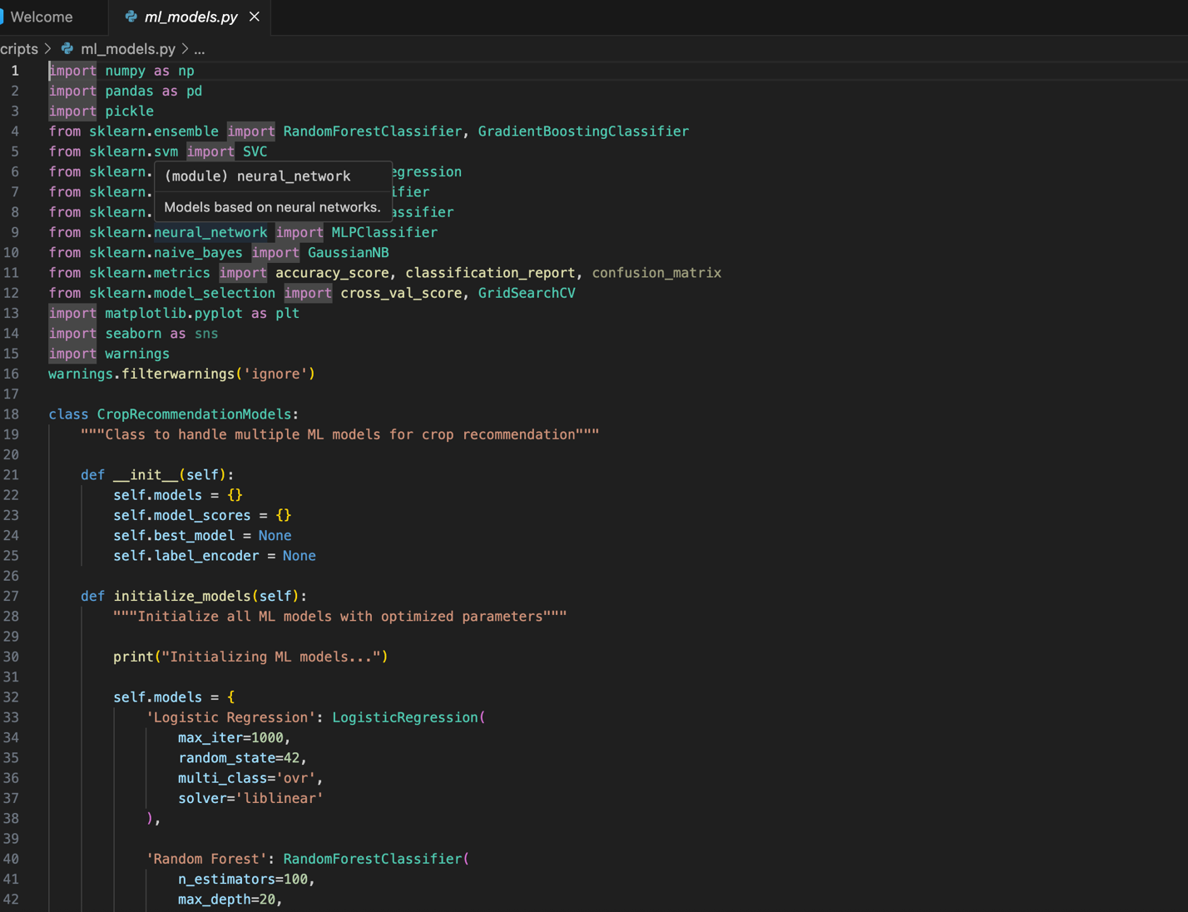
  - model_evaluation.py
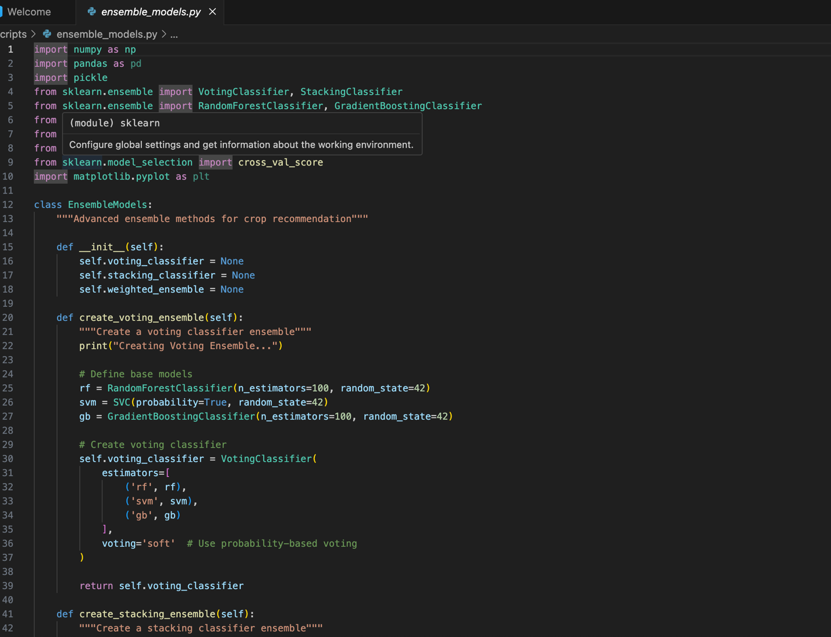
  - model_interpretability.py
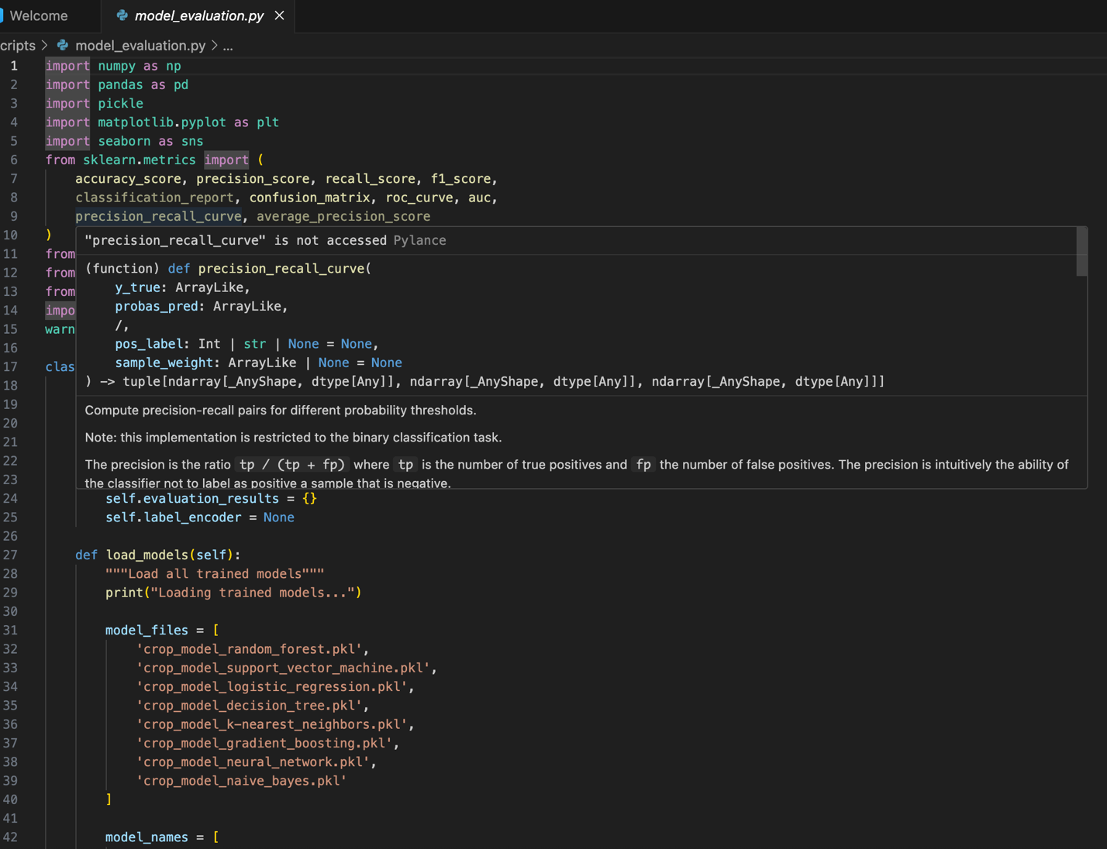
  - streamlit_app.py
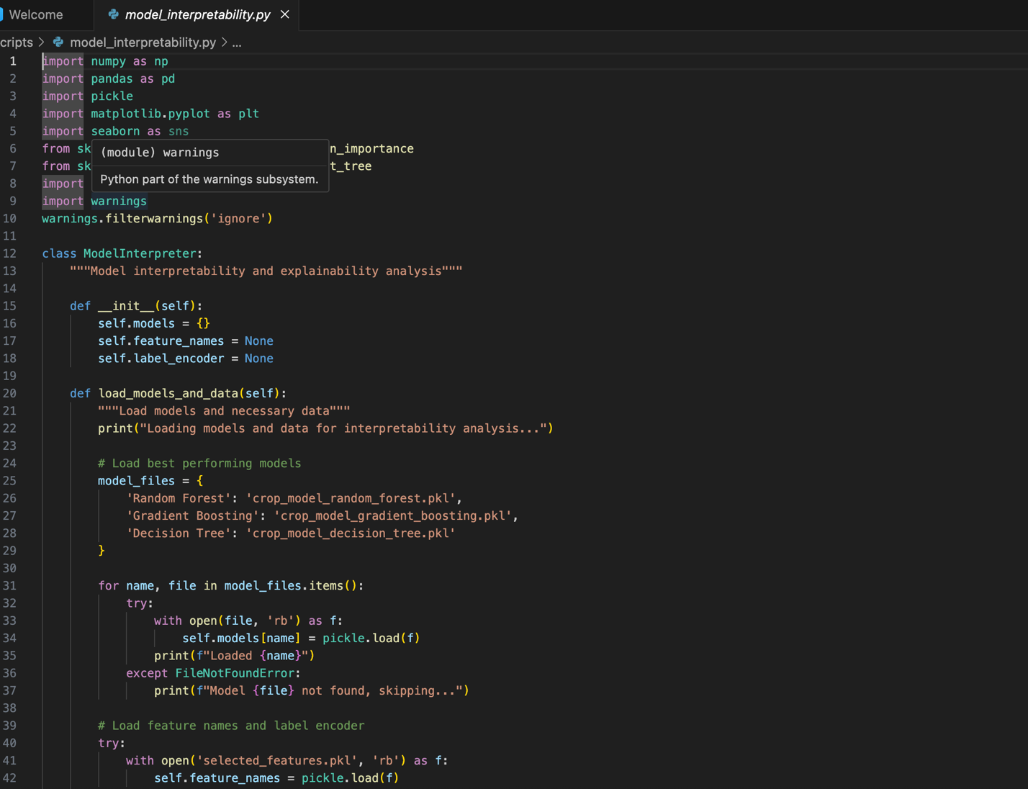

Deployment

Objective:

The deployment objective was to make the trained machine learning models accessible through an interactive and user-friendly web interface that allows users to input train details and get predicted delay categories in real time.

Tools and Technologies Used:

- Python: For building the entire pipeline including preprocessing, modeling, and inference logic
- Streamlit: For developing the interactive web interface
- Pickle: For saving and loading trained models, imputers, and encoders
- Pandas & NumPy: For data manipulation
- Scikit-learn & XGBoost: For training and predicting using ML models

Deployment Architecture Overview:

The deployment architecture is designed to be modular and scalable. It uses a central Streamlit app (`app.py`) placed at the project root, and each trained model is stored in a dedicated directory. Each model directory includes the trained model file (`model.pkl`), input columns used for training (`model_input_columns.pkl`), and imputer (if needed).
When a user selects a model and submits input values, the app dynamically loads the corresponding model, applies the preprocessing logic, ensures that the feature columns match, applies imputation if required, and finally provide recommended crop.

Project Folder Structure:

The following directory structure is used to organize the project:
📁 project-root/
│
├── streamlit_app.py
├── run_complete_pipeline.py
├── data_analysis.py
├── feature_engineering.py
├── ml_models.py
├── ensemble_model.py
├── model_evaluation.py
├── model_interpretability.py

Key Insights & Impactful/Important Features

Key Insights
- The model demonstrated that soil nutrient composition (N, P, K) significantly influences crop selection, with nitrogen and potassium levels being major determinants of productivity.
- Temperature and rainfall were found to be strong climatic indicators affecting the growth cycle and adaptability of crops. Regions with moderate rainfall and temperature variability were suitable for a wider range of crops.
- The pH value of the soil acts as a critical threshold parameter—most crops perform optimally in neutral to slightly acidic conditions (pH 6.0–7.0).
- Machine learning algorithms, particularly Random Forest, provided high accuracy and interpretability, showing robust performance in handling non-linear relationships between multiple parameters.
- Feature importance analysis revealed that combining soil nutrients and climatic variables leads to more precise recommendations than using either type of data alone.

Important Features Identified

Nitrogen (N): Affects leaf development and vegetative growth; critical for cereals and leafy vegetables.

Phosphorus (P): Enhances root strength, flowering, and seed formation.

Potassium (K): Improves water retention, disease resistance, and overall crop resilience.

pH Value: Determines nutrient solubility and microbial activity in soil.

Rainfall: Influences irrigation planning and crop selection, particularly for rainfed farming systems.

Temperature: Regulates germination, flowering, and maturity; crops like wheat and rice have distinct optimal temperature ranges.

Future Work / Scope of improvements
While the Crop Recommendation System in India demonstrates promising results in predicting suitable crops based on soil and climatic factors, there remains significant potential for enhancement and expansion. The current model relies on a limited set of features—mainly nitrogen, phosphorus, potassium, pH, rainfall, and temperature—collected from static datasets. Future improvements can focus on incorporating dynamic and real-time data sources to make predictions more accurate and regionally relevant.
One potential area of enhancement is the integration of IoT-based sensors in agricultural fields to collect live soil and weather data. This would enable continuous monitoring and on-demand crop recommendations. Additionally, integrating satellite imagery and remote sensing data could help assess vegetation health, soil moisture, and crop growth patterns over large areas.
Future versions of the system can also employ deep learning and ensemble hybrid models to improve prediction accuracy and adapt to non-linear relationships among agricultural parameters. The inclusion of economic and market data—such as crop demand, price trends, and input costs—can make the system more farmer-centric, helping them select not only the best crop for the soil but also the most profitable one.
From an application standpoint, developing a mobile-based multilingual platform would enhance accessibility for farmers across different regions of India. Furthermore, implementing GIS (Geographical Information System) mapping could allow visualization of crop suitability zones and promote region-specific agricultural planning.
In summary, continuous enhancement through advanced data collection methods, deep learning algorithms, and real-time integration can make the Crop Recommendation System a powerful and scalable solution. Such improvements will contribute to sustainable agriculture, higher yields, and better decision-making for Indian farmers in the long run.

Checklist of items for the Final report

- Is the Cover page in proper format? Y
- Is the Title page in proper format? Y
- Is the Certificate from the Mentor in proper format? Has it been signed? Y / N
- Is Abstract included in the Report? Is it properly written? Y
- Does the Table of Contents page include chapter page numbers? Y
- Does the Report contain a summary of the literature survey? N
  - Are the Pages numbered properly? Y
  - Are the Figures numbered properly? Y
  - Are the Tables numbered properly? Y
  - Are the Captions for the Figures and Tables proper? Y
  - Are the Appendices numbered? N
    - Does the Report have Conclusion / Recommendations of the work? Y
    - Are References/Bibliography given in the Report? Y / N
    - Have the References been cited in the Report? Y / N
    - Is the citation of References / Bibliography in proper format? Y / N

